Ideation Phase
Empathize & Discover

Date | 06 July 2026
Team ID
Project Name | Online Complaint Registration System
Maximum Marks | 4 Marks

Empathy Map Canvas:
An empathy map is a visual tool used to understand users' thoughts, behaviours, needs, and challenges. It helps identify user expectations and design solutions that provide a better user experience.
The Online Complaint Registration System empathy map focuses on understanding the problems faced by users during traditional complaint registration and resolution processes.

Example:
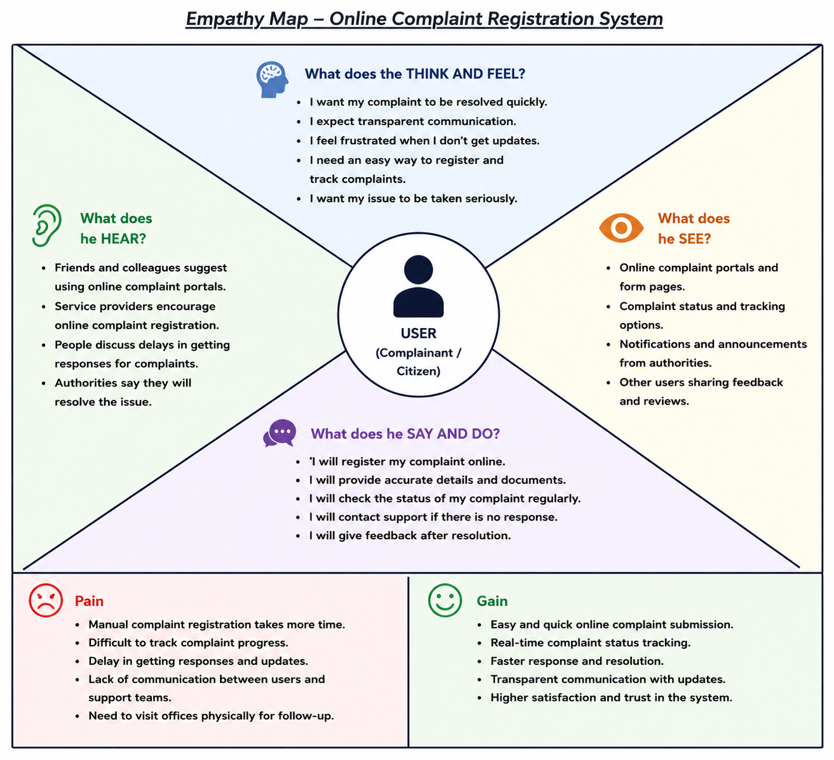

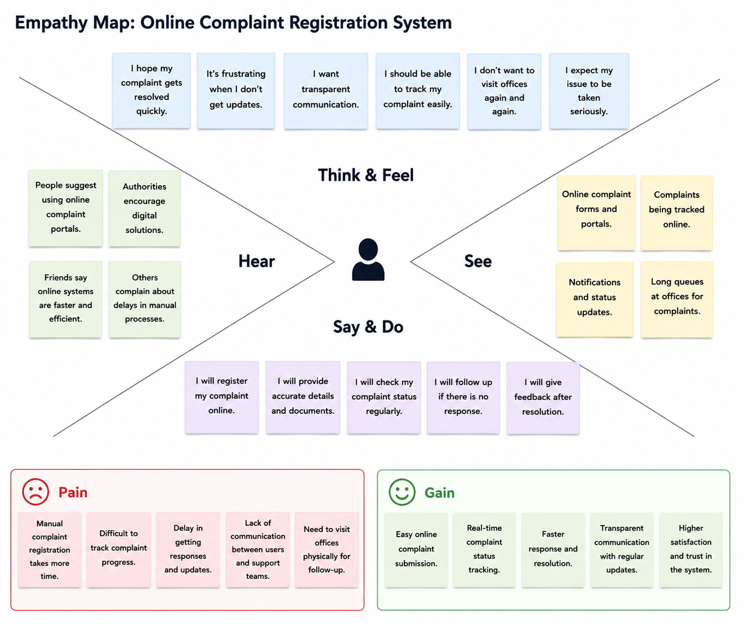
Reference: https://www.mural.co/templates/empathy-map-canvas

